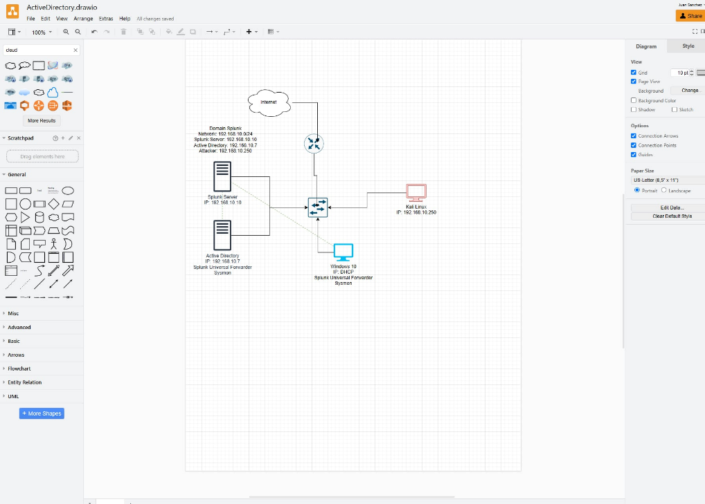

Sysmon & SplunkForwarder established

Splunk Endpoint established

Splunk Endpoint event reporting receiving events

Set up Sysmon and splunk on both devices, and configure endpoint reporting to receive reports

DC1 set to Active Directory Manager, user accounts added for IT and HR departments, and users.

Target computer users assigned, RDP established, connection to Active Directory Server established.

Kali Linux Machine, Password list established

Crowbar installed

Target located, assumed used nmap for enumeration, IP of kali machine changed to match the same 192.168.10.0/24 Network as target for ease. Crowbar launched against target machine, password found.

Event logged and located on Splunk server, multiple counts of failed login attempts identified, code 4625 ~20 attempts all at the same time, indicating brute force attempt.

Kali virtual machine identified on event code 4624, successful login. IP address logged.

Installed Git

Git not recognized, added to path

Git resolved, Atomic Redteam Files downloaded, Firewall exclusion on C:/ drive prevented antivirus from interfering

Installing atomic red team

After Atomic Red Team is installed, Invoke-AtomicTest T1136.001 to create a New Local Account ‘NewLocalUser’

Event Captured in Splunk

Attempt additional attacks on target machine: T1059.001, PowerShell attacks

Windows defender detected and blocked multiple threats

Events logged and detected on Splunk

